Lesson Plan

LESSON PLAN | Subject: Math (Addition)
Trainee:  Rouda Ahmed | Topic or Theme: Weather and sky
Class: KG2.3 | Date & Duration: 25/3/2019
Trainee Personal Goals
I would like to use the behaviour management and positive reinforcement and stop using negative reinforcement to check if its work or not.
Lesson Focus (smart goals)
- By the end of the day 75% of students will be able to add two groups of objects together.
Lesson Outcomes:
Students will be able to learn how to add two groups of objects.
MATHS: K2.1.1.3.1-Recognise the concept of addition as a process of combining two groups of objects.

Links to Prior Learning:
The student should be able know the numbers from 1-10 and how to count one- to one corresponding.
21st Century Skills
The 4c’s:
Critical thinking: students will think how to solve the problem and how many objects they need for each number.
Collaboration: two students will collaborate and share materials during the centers.
Communication: two or maybe three students will communicate, discuss and share their experience while they are working and during the carpet session.
Key vocabulary
Addition, plus, equal, add, symbols: + =, bigger, sum.
Possible problems for learners  The student might keep taking and miss behave during the lesson.  Student might not understand the vocabulary plus, equal and add. |  | Solutions to possible problems  Use ClassDojo, stickers, high five to manage the student behaviour.  Tell the student the meaning of the vocabulary in Arabic.
Resources/equipment needed
Activity 1: numbers card, small shapes, paper and pencil.
Activity 2: cards and cloths pin
Activity 3: unfix cubes, addition card, marker, white paper and pencil,
Activity 4: pencils, dice, straws, big shapes, paper and pen.
Activity 5 (focus): White board, markers, rubber.

 | TASKS/ACTIVITIES
Resources  & Time | Introduction
10 – 15 mins | Teacher will:  Morning circle:  - Day of the week: today is Monday.  - Attendants with student teacher.  - What’s the weather outside?  Then I will start explaining. (Today we will learn about addition)  I will start my lesson by dividing the students into two groups of boys and girls then I will ask my student helper to count how many boys and how many girls, then add them together.  - I will write 1 + 1 on the whiteboard then I will ask students if they know what this means. I will put one pencil in one hand, and one pencil in my other hand. I will show children that this means one (pencil) and one (pencil) together equals two pencils. I will bring my hands together to reinforce the concept.  - Then I will explain to the class that when we put things together, it is called addition, or we add. Also, I will say that addition means It is getting bigger.  I will use the technology and my PowerPoint as an engagement.  I will go through the PowerPoint and I will ask them how many moons will have if we add 2 moons and 1 moon?  After they answered I will show them the next slide to check if our answer is right or wrong.  And I will ask one student to come and write the sum down before showing them the answer.  There is different level for the student.  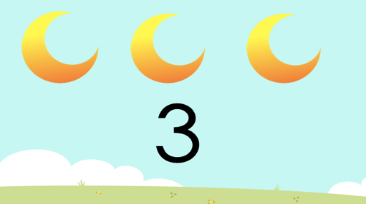  Students will:  Student helper will help and divide the students to two groups (boys and girls).  Then s/he will write how many boys and girls in the board. Then together will add them to have how many students in the class.
Resources  & Time | Main activities (Math)
20-30 min | Activity 1:  (individual)  The student will choose numbers then they will take manipulatives depending to the numbers that they choose then they will put them inside the box, next they will open the mouth of the box and count how many objects they have.  After they finish the game they will write the equation (sum) on a piece of paper.  21st century skills:  Critical thinking: student will think which number to choose and how many they will get?  Collaboration: the student will share and collaborate using the box and the materials.  Domains development  Physical domains: fine motor skills- student will use their finger to put the objects inside the box and while they are playing with the box, also when they will hold the pencil.  Teacher will:  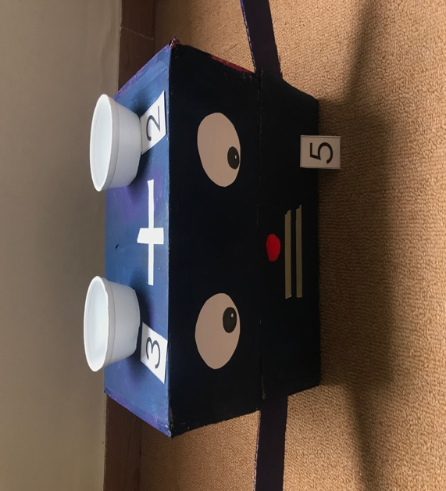
Activity 2:
(individual)
The student will have different levels of cards the emergent level will be able to do from 1-5, developing student will be able to do from 1-10, and mastered students will be able to do from 1-15.

21s century skills:

Critical thinking: the students will think how many moons, stars and suns there are and will count by their sight to find the answer.

Collaboration: student will share the cards and the material.

Domains development:
Physical domain: fine motor skills- students will use the hands and finger to hold the clothes pin and put it on the right number.
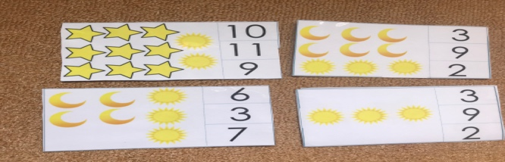

Activity 3:
(individual)
The student will solve the sum using the unifix cubes. First, they will have easy equations, then medium and finally they will have the harder equations.
21s century skills:

Critical thinking: student will think to solve the different equation and how many cubes do they need.

Collaboration: student will collaborate and share the unfix cube while they are solving problem.

Domains development:
Physical domain: fine motor skills- students will use the hands and finger to

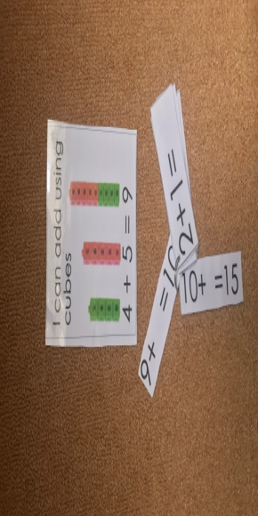
Activity 4:
(individual)
The student will use the hands paper to create their own equation. First the student will use the fingers to count and add the numbers. And to help them add they are going to use straws.
The other type is on the floor the student will through the dice twice and write the number down then they will use the big shapes to help them add and find the answer.
21s century skills:
Critical thinking: student will think to solve the different equation.
Domains development:
Physical domain: fine motor skills- students will use the hands and finger to write the equation on a piece of paper.

And

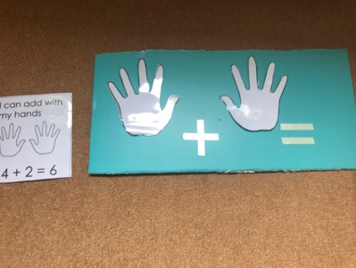
Activity 4: (focus)
Students individuals will have board and marker and I will says for example 2+2= and they should write down the sum with the answer and I will be able to know the student’s level and ability. And for the student who have difficulty to count I will tach them to use the dots and unfix cube to help them add.
21s century skills:
Critical thinking: student will think how to solve the different equations.
Domains development:
Physical domain: fine motor skills- students will use the hands and finger to write the equation on the board using the marker.

Resources  & Time | Plenary/Conclusion
5-10 mins | Students will  As a whole class the student will share their work with their teacher and friends. |  |  | Teacher will  The teacher will ask the students who finish their work to come and describe it to the classroom. Do not choose every child!
Homework | No homework.
Assessment Strategies: | I will make cards with some pictures and cards with numbers I will ask the children to answer, the answer will be in the back of the card. Where will this go?  1 + 3 =  + =
☐ Observation |  | ☐ Student self-assessment | ☐ Oral questioning |  | ☐ Peer assessment
☐ Quiz |  | ☐ Student presentation | ☐ Written work and feedback |  | ☐ Verbal feedback

Reflection:

