Lesson Plan

LESSON PLAN | Subject: Math and science
Trainee: | Topic or Theme: Weather and sky
Class: KG2/4 | Date & Duration:
Trainee Personal Goals
I would like to use the behaviour management and positive reinforcement and stop using negative reinforcement to check if its work or not.
Lesson Focus (smart goals)
- At least 75% of students will be able to use the ordinal numbers 1st, and last to describe the order of objects people or events.
- By the end of the day 75% of the student will be able to describe and identify the characteristic of day and night.
Lesson Outcomes:
Math: K1NS6: Use the ordinal number words first second and last to describe the order of objects, people and events.
Mastered: Use the ordinal number words first second and last to describe the order of objects, people and events.
- Developing: use the ordinal number words ‘first’ and ‘last’ to describe the order of objects, people or events.
- Emerging: use the ordinal number word ‘first’ to describe the order of objects, people or events.

Science: KES1: Describe characteristic of day and night.

Mastered: Describe characteristic of day and night.
Developing: Identify characteristic of day and night.
Emerging: illustrate characteristic of day and night.

Links to Prior Learning:
Students should know the sun, moon, and stars. And how to recognize things and put them in order.
21st Century Skills
The 4c’s:
- Communication: discuss about the similarity and difference (routines, sequence events, what they can see in the sky during day time?) between day and night.
- Critical thinking: student will think about the different events in day and night before they draw.
- Creativity: the student will think and create day or night on the plate using paints.
- Collaboration: students will discuss and collaborate to sort the different events in day or night.
Key vocabulary
First, Second, third, up to tenth. Last.
Morning, day, night, moon, sun, stars.

Possible problems for learners  Students might not know how to put it in order.  Student might don’t know what day and night are. |  | Solutions to possible problems  Show the student how to put the daily routines in order and ask them what will come next?  And make sure to say first second and last.  Show them pictures of day and night. And ask them what is the difference between the two pictures? (guide them to the answer).  What can you see in this picture?  Is it day or night?  How do you know?  What do you do during day/night?
Resources/equipment needed
Activity 1: papers, crayon, water color and pencils.
Activity 2: paper laminated with different daily events.
Activity 3: Different colors of beads.
Activity 4: colors, picture and paper

 | TASKS/ACTIVITIES
Resources  & Time | Introduction
10 – 15 mins | Students will:  Listen to the teacher and answer the question. | Teacher will:  Read the “what I do in my day” story using the puppet and using the CROWD strategies.  - What time of day do you wake up to go to school? During the day time or the night time?  - When you wake up in the morning, what you can see in the sky?  Before you eat your dinner, what you can see in the sky?  - What is an activity you do only when it is dark outside? (read a bed time story,)  - What did Mariam do in day/ night time.  - What is an activity you do only when it is light outside? (go to school, eat breakfast, etc.)  - What comes after daytime? Night-time? Does this pattern ever stop?  - Explain the activity 3-5 mins
Resources  & Time | Main activities
 | Students will (group)  Think about the story and think what they used to do in day and night and draw it in a paper.  Students will create a day or night using a wax resist technique and they will draw their characteristics.  After they finish I will put the students in pairs (one of them with day and the other with night) so they are going to discuss the difference and similarities between them. | Teacher will:  (create night sky with some activity and discuss)  The teacher will guide the student to draw using the questioning.  - What is an activity you do only when it is dark outside? (day and night story)  - What is an activity you do only when it is light outside? (go to school, eat breakfast, etc.)  - What comes after daytime? Night-time? Does this pattern ever stop?  - When you wake up in the morning what is the first thing you do?  - What do you before going to sleep?  - When are you going to sleep?  - When you wake up in the morning what is the first thing you do?  - What is the last thing you do before going to sleep?  The student will have pictures from stories to help them to draw.
Math center (focus)
First I will re read the story with the student and asking them questions:
What is an activity you do only when it is dark outside? (day and night story)
What is an activity you do only when it is light outside? (go to school, eat breakfast, etc.)
What comes after daytime? Night-time? Does this pattern ever stop?
When you wake up in the morning what is the first thing you do?
What do you before going to sleep?
When are you going to sleep?
When you wake up in the morning what is the first thing you do?
What is the last thing you do before going to sleep?
The students will order the daily events of their lives by first, second, third, last…. up to the end.
I expect the mastered student will be able to put their daily events in order but for emerging and developing we can help them by giving them one event and they can find out what is after and before.

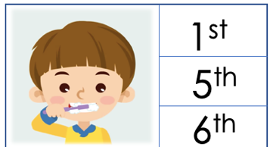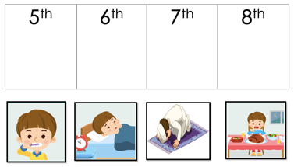
English center
‘Focus at night’
Students will write either “At night_______.” Or “in the day____.”. and to fill the blank they will choose activity from the story and they will write it down.
21s century skills:
Critical thinking: students will think what they will draw to present the activity.

Domains development:
Physical domain: fine motor skills- students will use the hands and finger to hold the pencil and colors.
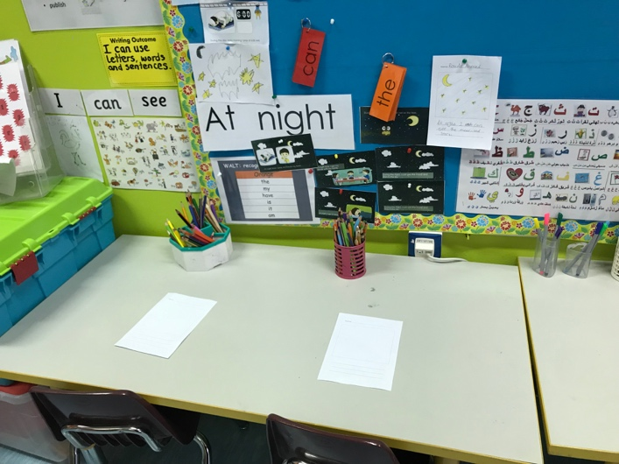
Science center:

‘Focus at night’
Students will put the stick the stars on the A5 paper then using the crayon they will draw the moon, then using the paints and sponge they will color over the stars and finally they will take the stars from the paper.
4c’s century skills:
Creativity: student will use paint to create sky in the night. Also, student will draw using some crayon the moon and stars.
Collaboration: student will collaborate and share the materials together.
The domain of development:
Physical domain: fine motor skills- student will use their fingers and hands to hold the crayon and sponge to paint and paper.
Gross motor skill: walking around the classroom and find the name for the checklist.
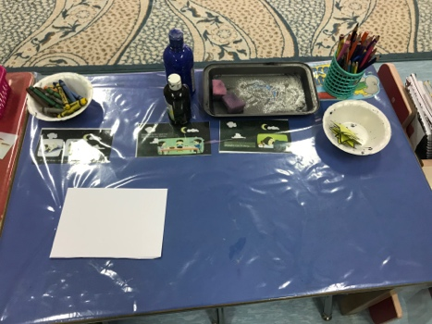

Role play:
In the role play the student will have tent and inside the tent they will have: stars, moon, owl, bat, night activity, blanket, pillow, teeth brush, light, animal stich for the shardow.
Two students will have checklist tent and then they will go to the tent night and they will search for the owl, moon and star. Then they will walk around the classroom to write the names of the owl, star and moon. When they finish they will go and play by pretend doing the night activity.
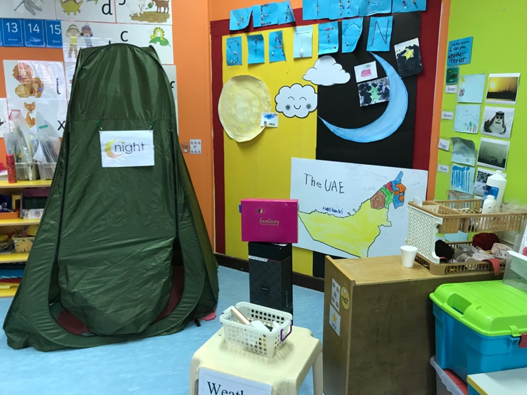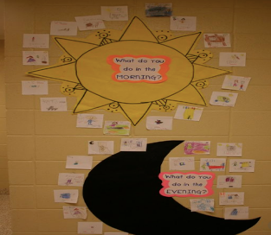

Resources  & Time | Plenary/Conclusion
5-10 mins | Students will  Describe their work in the centers, then they will discuss about the different about day and night. And then sort the events with the teacher in the Venn diagram. |  |  | Teacher will  Ask the student to discuss about the different between day and night and the different routines, then she will draw a Venn diagram and ask them to sort the different events in day and night.  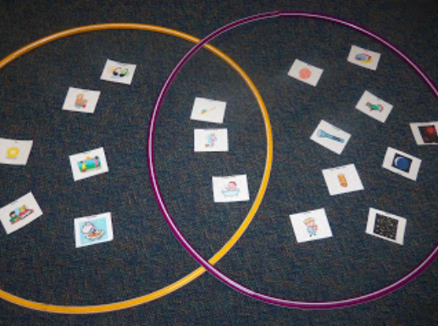
Homework
Assessment Strategies: | - As a whole class  I will show the student difference pictures and activities during day and night. Then I will ask them when do you do this activity in the day or the night?  Ans students will answer me using the sticks either day or night.  If I finish early I will ask one student to come and pretend doing something and we should guess is it day or night.
☐ Observation |  | ☐ Student self-assessment | ☐ Oral questioning |  | ☐ Peer assessment
☐ Quiz |  | ☐ Student presentation | ☐ Written work and feedback |  | ☐ Verbal feedback

Reflection:

