Date & Duration of lesson | Number of students |  |  | Class / Grade
7 of Nov | 24  25 |  |  | KG2
Personal Aims
- Finish each activity on time and don’t get stress. (Goal)
- Practice and make sure everything ready before the lesson; use a timer for each part of the lesson; ask my MST to guide the other students while I am with the focus group; use the same routines and procedures as the MST for all the transitions (Strategies Used)
- If I can complete all the activities in my lesson plan. (Evidence)
Learning Outcomes:  (Link to the ADEC K-5 curriculum document) |  | Materials
KES1: Identify characteristic of the seasons in the local area.  - Emerging: Illustrate the characteristic of seasons in the local area.  - Developing: Label the characteristic of the seasons in the local area.  - Mastered: Identify the characteristic of the seasons in the local area.  KWWP2: share their writing with teacher and peers.  KLTC1: follow two or more step directions. |  | papers  colors  Pictures representing the seasons  Hooks  pictures
Lesson Introduction
Whole group activity: Time_10 -15 min
Warm Up/Introduction:
“Yesterday we learned about cold and hot, Today I’m going to teach you about the four seasons of the year: Summer, winter, fall and spring. (reading seasons story)”

Active Engagement:
Now guys you are going to the centers and remember the seasons: summer, winter, spring and winter

Introduction:

Teacher: Good morning KG2
Student: Good morning Ms. Rouda
Teacher: How are today?
Student: Fine thank you, how are you?
Teacher: Fine thank you.
Tr: today is Wednesday, yesterday was Tuesday tomorrow will be Thursday all day long all day long.
Sing the sing with the kids.

Starting:

Teacher: Today you are going to learn about the seasons: summer, winter, fall and spring. (with showing them at the board) Who knows what the four seasons are?
Student x: summer, fall, spring and winter
Teacher: wow you are right, who knows which season we are in?
Y: Winter
Tr: yes, you are right. Let’s read a story about my friend Mansoor who met some animals who were very interesting. (Show Mansoor. Talk to Mansoor – hi Mansoor. How are you? Did you find out anything about the seasons? Mansoor answers and says let’s read)
Student: yes
Teacher: our story for today is: seasons
Follow the PowerPoint slides to read the story.

Teacher: now which season do you like?

Link:
“Today, while you’re at your learning centers, you need to remember that we are learning about 2 different seasons called summer and winter”.
Question (Blooms Taxonomy):
What do you do in the winter?
What do we do in the spring?
What do we do in the fall?
What do we do in the summer?
Which fruit grows in the summer, winter?
What do you think we should wear in the winter?

Who knows what are the four seasons?

Learning Center Resources or Materials
Learning Center 1  Math | Learning Center 2  Science | Learning Center 3  Art | Learning Center 4  English
Dice  Paper  Playdough  Numbers | Pictures  Hooks | Colors  Paper  Pictures representing the seasons | papers  colors  pictures
Learning center 5
Focusing group:
Pencil
Paper
Color
pictures

Small Group Learning Centers: Time 20- 30 mins
Focusing group:
The student will sort pics cards for summer and winter. First on the carpet the student one by one will choose picture and then will think does the cards show summer or winter? After the student will finish we will go to the table and there each student will have paper and pencil they will write their names at the top, next they will choose pics to draw and color it, last they will label what they draw fir example if she/he draw sun they will label the sun and they will write either its summer or winter.

Learning Center 1 (Math):  More and less they will have a sheet with two circles with more and less, dice, and playdough. The student will throw the dice twice then using the playdough they will represent each one and they will discuss which is more and which is less. Maybe also have numbers as the dice only goes up to 6.  Starting:  Teacher (explain the activity): First you will throw the dice okay? Which number do we get?  Student: 2  Tr: okay, throw the dice again now which number do we got?  St: 6  Tr: which one more 2 or 6?  St: 6  Tr: excellent and which one less?  St: 2  Tr: good, you will make 6 balls using the playdough, and 2 balls, who can come and show me the number 6 using the playdough? who can come and show me the number 6 using the playdough?  (the student will come and represent the numbers 6 and 2 using the playdough)  Tr: thank you, then you will find the number 6 and 2 and put it under the playdough. Can you do it for me?  St: yes  The domains that they will using it in this activity:  Physical domain: fine motor skills – the student will use their fine motor skills when they will throw the dice and playing with the playdough to represent the number.  The 4c’s that are using in this activity:  Critical thinking: the student will think which number is more and which one is less? How many balls they will create to represent the number?  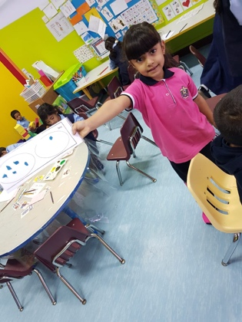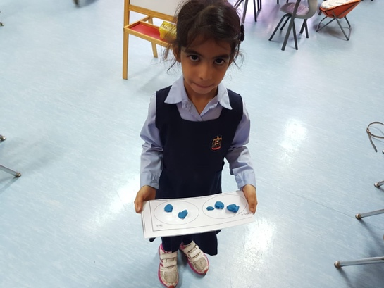  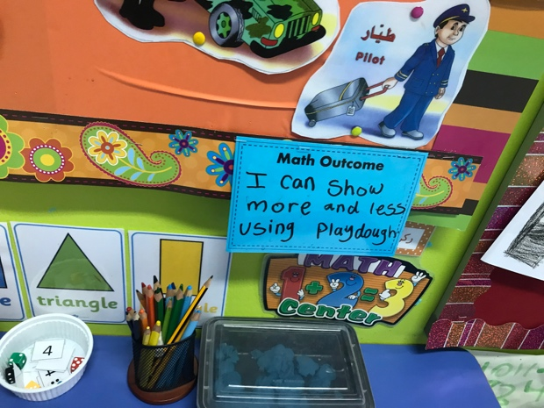 |  |  | Learning Center 2: (Science)  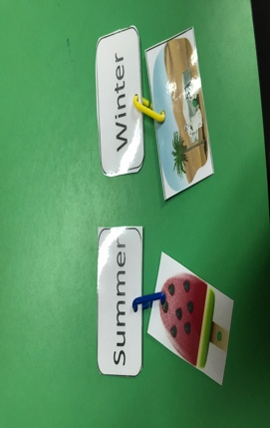  The student will have pictures of summer and winter and the will connect that represent the season under the season using the hooks.  Starting:  Teacher (explain the activity): First you will find the summer and winter, who can find for me S S Summer?  Student: will come and find for me the summer card  Tr: good job, who can find for me W W Winter?  St: will come and find for me the winter card  Tr: then you will think and find for me the picture that shows summer and you will put it like this (showing them) using the hooks. Okay?  St: okay  Tr: good job.  The domains that they will using it in this activity:  Physical domain: fine motor skills – the student will use their fine motor skills when they will use the hooks to connect between the cards.  The 4c’s that are using in tis activity:  Critical thinking: the student will think and remember which picture is in summer and which one in winter.  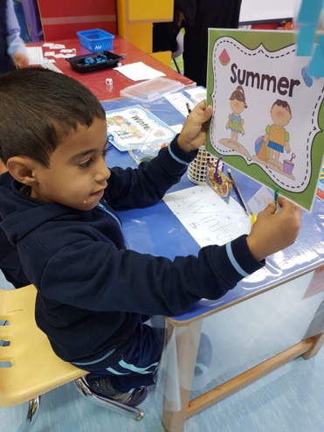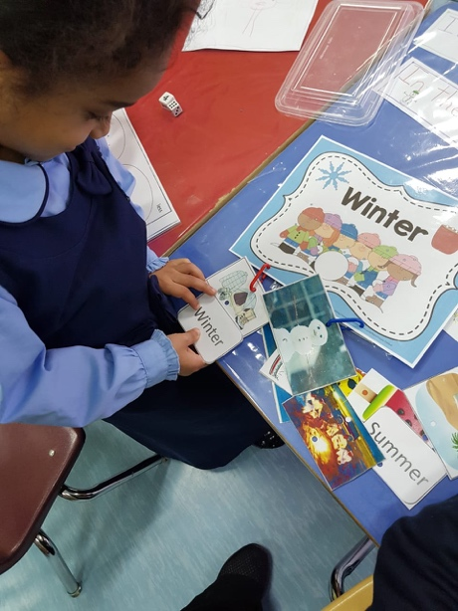  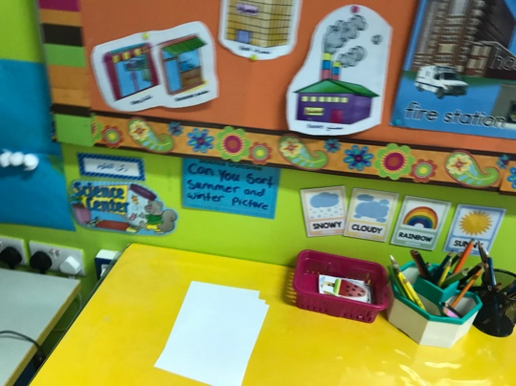
Learning Center 3 (creative):  They will think and communicate about the pics in front of them different pics in each season and what they remember in the story. They will use the colors to draw or represent what they have or do in winter and summer season using finger painting technique.  This activity I will explain it with the group.  Tr: write your name in the top of the paper, from left to right.  Tr: salma, which is your favorite season summer or winter?  Salma: summer  Tr: write it down Summer.  Tr: okay what do you eat in summer?  St: ice cream  Tr: what does the weather look like? Sunny? Cloudy?  St: sunny.  Tr: okay  The domains that they will using it in this activity:  Physical domain: fine motor skills – the student will use their fine motor skills when they will put their fingers on the painting and drawing to represent the finger.  Social domains: the student will share the colors with their friends.  The 4c’s that are using in this activity:  Critical thinking: the student will think which season they like and which color they will choose to represent the season.  Communicate: the teacher will asking question to guide them to which season they want to draw and which color they will need? If they choose a pic to draw. The teacher will ask them Is it in winter or summer?  Creative: the student will choose which colors represent the seasons or they can see it in summer season for example the yellow, orange, red, green. And they will create their favorite seasons using finger painting.  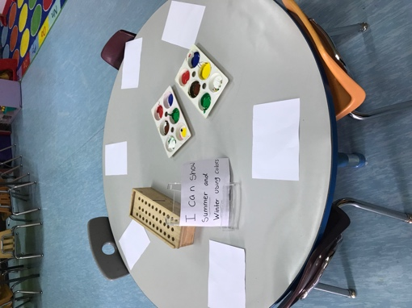  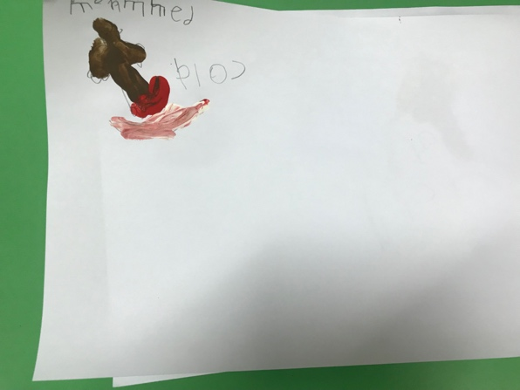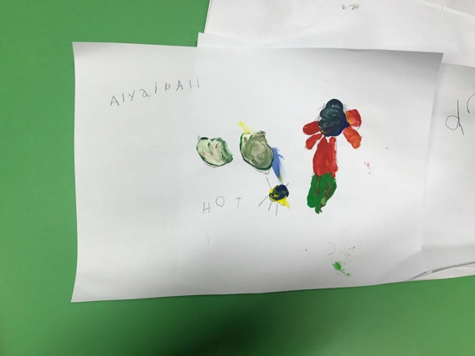 |  |  | Learning Center 4: (English)  The student will write ‘I like summer or winter’ they will have the sentence ‘I like’ on the wall in front of them, they will copy and depending at the pictures they have of summer and winter they will choose which season they like.  Starting:  Teacher (explain the activity): First you will think which season do you like? MS. Rouda like the summer. So I will write I like Summer, then I will think hmmm what do we have in summer?  St: Ice cream  Tr: yes, we eat ice cream in summer, I will draw Ice cream and I will draw the dates, the dates grow in summer, right?  St: yes  The domains that they will using it in this activity:  Physical domain: fine motor skills – the student will use their fine motor skills when they will hold the pencil and colors to write the sentence, draw, and color.  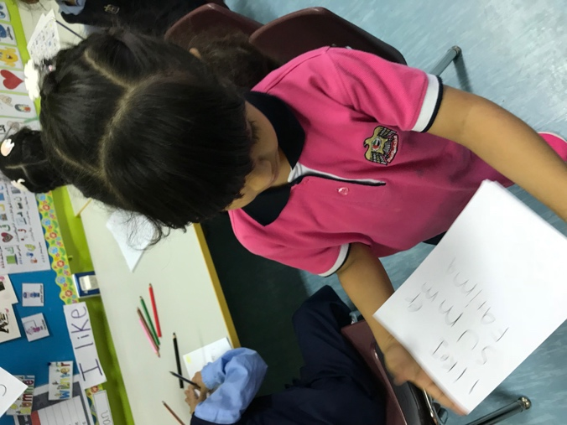  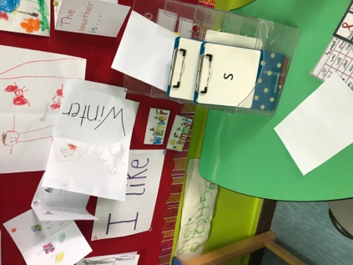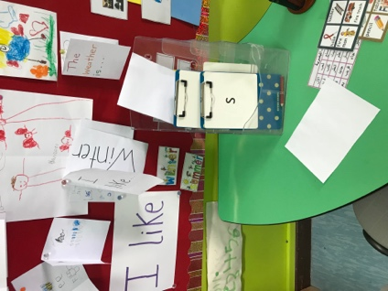
Closing activity: Time: 10-15 min
Whole class - comment and questions. This allowed the teacher to identify if students understood the characteristic for each season.
Learners will talk about their drawing.
Discuss what we learnt today.
Assessment for Learning:
Ask question? And they answer (bloom taxonomy) me with their thumbs. Or using the stick summer and winter.

- Students will go through the 4 centers they will learn how to Write the (spring, fall, winter and summer), how to differentiate between them, and what we wear in each season.

